Colombian women are calling on their government to address the following demands to protect the rights of rural women defenders in Colombia:

- Promote a preventative approach. Specifically, the Ministry of the Interior should take leadership to address the recommendations issued by the Early Warning System of the Colombian Ombudsman (Defensoría del Pueblo).

- Recognize the work of women defenders of territorial, environmental and agricultural rights.

- Guarantee the participation of women defenders of territorial, agricultural and environmental rights in decision-making processes at the national and local levels.

- Ensure that protection mechanisms under the National Protection Unit incorporate an ethnic, territorial, differentiated and collective approach.

- Support community councils of black and Afro-Colombian communities, indigenous authorities and small farmer communities by strengthening their own self-protection instruments.

- Uphold and promote recognition of the rights of small farmers and their communities.

- Allocate resources to enable development and implementation of the comprehensive security and protection program for communities and organizations at the territorial level and of the comprehensive guarantee program for women leaders and human rights defenders.

- Ensure that the resources allocated provide appropriate and differentiated funding in order to guarantee the full participation of rural women defenders.

- Guarantee the participation of women defenders of territorial, agricultural and environmental rights in creating protocols to integrate a gender approach in all measures and mechanisms.

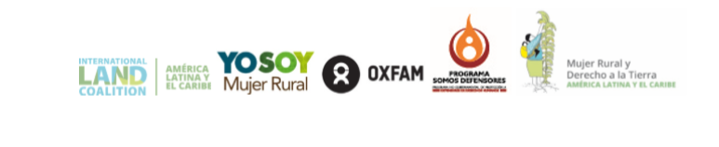
Citizens should join together for the protection of rural women defenders and develop social sanction mechanisms against attacks and murders.

